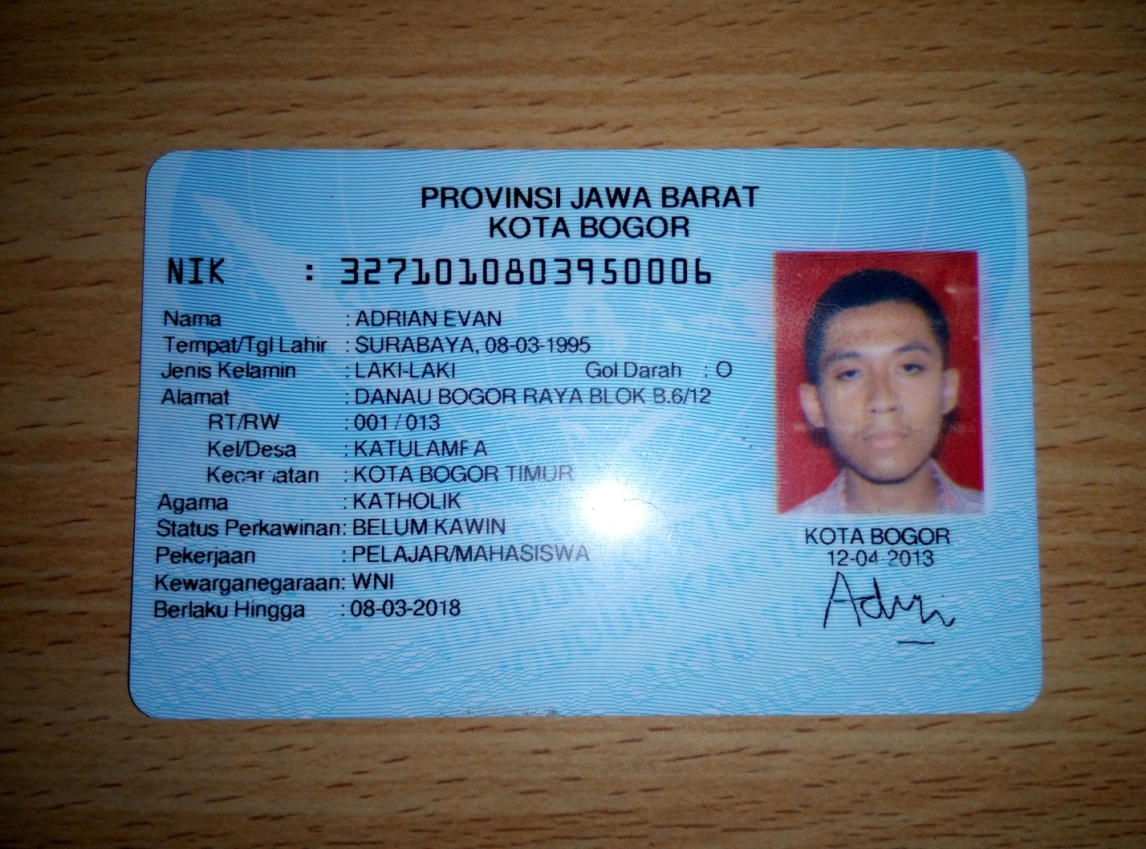PIN website: 141414

Nickname: Pattiserie, BX-sundaeFM17, adrianevan-Ru, adrianevanRu, BiP--AdrianEvan

Email verif: yohanesadrianevan@gmail.com

Kode voucher:

CLEH-MATV-UBMS

ETFE-LJMQ-AXQC

QBMX-DVDA-CMXZ

KDGH-WBBH-XECV

QQMG-DXSE-FHXQ

Email pengganti: rikoekana@gmail.com

Game yang dimainkan: Audition AyoDance

id: japan44kaz

pw: a12bc34d